EzFare

Requirements Definition

Version 1.1

Doc. No.:

Revision History

Date | Version | Description | Author
2010-10-01 | 1.0 | Initial requirements | Mislav Stipetic
2010-10-14 | 1.1 | Requirements amendments – Fully dressed use case. Added some requirements for the future versions. | Vice Simunov
2010-11-23 | 1.2 | Addition of Introduction, Uses Cases added and edited existing ones, other minor changes. | Kaushik Mohanraj
2011-01-08 | 1.3 | Minor changes | Lidia Kahsu

Table of Contents
1. Introduction 4
1.1 Purpose of this document 4
1.2 Intended Audience 4
1.3 Scope 4
1.4 Definitions and acronyms 4
1.4.1 Definitions 4
1.4.2 Acronyms and abbreviations 4
1.5 References 4
2. Requirements Description 4
2.1 Introduction 4
2.2 General requirements 5
2.3 Requirements for supporting various public transportations types 5
2.4 User tracking and informing 5
2.5 Payment 5
2.6 Non-functional requirements 5
3. Use Case Models 6
3.1 Use case model: Web application tasks 6
3.1.1 Use case user registration 6
3.1.2 Use case transfer funds into prepaid account 7
3.1.3 Use case account deletion 7
3.2 Use case model: User interaction via mobile phone 8
3.2.1 Use case taking a ride on the public transportation vehicle (FULLY DRESSED) 8
3.2.2 Use case traffic problems 9
3.2.3 Use case better route suggestion 9
3.3 Use case model: System administration 10
3.3.1 Use case beginning customization 10
4. Requirements Definition 10
4.1 Requirement Group Definitions 10
4.2 Requirement Sources 10
4.3 Requirements definitions 10
4.3.1 Change Logo 11
5. Future Development 12
5.1 General Overview 12
5.2 Modularity 12

Introduction
In today world Transport is the most essential part of any metropolitan. Public Transport constitutes to major part of Transportation development for any administrative body. Thus an effort to make Transportation/Commuting smoother for their consumers, an innovative ticketing procedure is been introduced.
This project aims in making the ticketing process for the customers a user friendly and hassle free. The project incorporates features such as Ticket issuance just by click button, route optimization, and notifications if you are a regular traveller, and so on and so forth. Hence, the name of the project is ‘EzFare’.

Purpose of this document
The purpose of this document is to provide an insight into the EzFare(Transport4you) project requirements, to describe the project's use cases to give a broad prospective of the capabilities of the entire system.
This document will also explain in detail the project requirements amassed from requirement specified by the official SCORE customers and team member inputs. The document will be explaining varied possible use-cases. As the project progress as per the development model that we have adopted the requirement details gets more specific and well-defined.

Intended Audience

The Intended Audiences of this document are:-
- The Team members to use as a reference during the Implementation phase of the project.
- The customer so as to understand the project scope.
- Team supervisor to have an overview of the project work.

Scope
The scope of the project is defined by the technologies involved into it. The system assumes that the customer would possess a mobile handset which is Bluetooth or Wi-Fi enabled and works on an Android Platform. The customer will be able to register into the system using the web application. The web application will be available to the customer for the already mentioned purpose as well as to the administrator so to moderate the system and have a hand on information for analysis and decision making.
The notification of ticket purchase will be notified on the Android application as well as the customer will be notified by an SMS.

Definitions and acronyms

Definitions

Keyword | Definitions
Mainframe | The mainframe of the system
SMS Gateway | A service that is outside of the SuD

Acronyms and abbreviations

Acronym or  abbreviation | Definitions
EzFare | EasyFare(Transport4You) project
SuD | System under design
VU | Vehicle unit
MTA | Metropolitan Transportation Authority
PG | Payment Gateway – an online transaction system
MA | Mobile application

References
- Project Homepage:
  - http://www.fer.hr/rasip/dsd/projects/transport4you2
- Project Proposal:
  - http://score-contest.org/2011/Projects.php#dinitto

Requirements Description

Introduction
This product’s final result will allow the user to quickly and easily manage information about various public transport systems, as well as allow a unified interface for purchasing tickets for using them. The user will interact with the system using his mobile phone. The emphasis will be on the usability for the user, as well as security and system stability.

General requirements
The project goal is to develop a system that unifies the services a public transport system offers and allows the user to interact with them using his mobile phone. The user should be able to easily view the information necessary for his journey, as well as be able to pay for it. Usability is a major aspect of the user experience, as a wide array of users, with different levels of technical proficiency will be using it. Different methods of payment should be offered. The system should also track user’s usual routes and offer personalized suggestions as to improve or optimize it.
For the organizations providing public transport services, the system has to be highly customizable and scalable, as it needs to be able to adapt to various payment models, user types, traffic loads and route topographies.
Also, a Web interface should be available, for various administrative and informational tasks.

Requirements for supporting various public transportations types
The system should be customizable to various public transportation types, payment models, user profiles, route layouts, etc. All modes of public transportation should easily be integrated into the system, using a well defined information structures. Highly modular system architecture is necessary, so that the public transportation service providers should define their transportation network layout only once, and the rest of the application should adapt, without any major interventions from the service providers.

User tracking and informing
The mobile application will be tracked and user’s usual routes will be noted and provide suggestions for its improvement. It will also automatically track if the user is on a Public transportation vehicle, and charge automatically for the trip the user undertook. The system should also inform the user if the route he normally takes is experiencing problems, or if the lines have changed.

Payment
The user of the Public transportation system should be offered various payment options, including prepaid account, deducting form his mobile phone carrier account, payment via SMS, etc. The price should be calculated automatically for his exact route. Also, proof of payment must be available (in this case it will be SMS user get after payment is done), so that the user can show it during inspections.

Non-functional requirements
One of major concerns is usability, as a wide array of user types, ranging from children to elderly are expected to use it, so usability and an intuitive user interface are critical.
The system must be stable, robust and adapt to changes, because money transactions are being done as one of its basic tasks.

Use Case Models

Use case model: Web application tasks
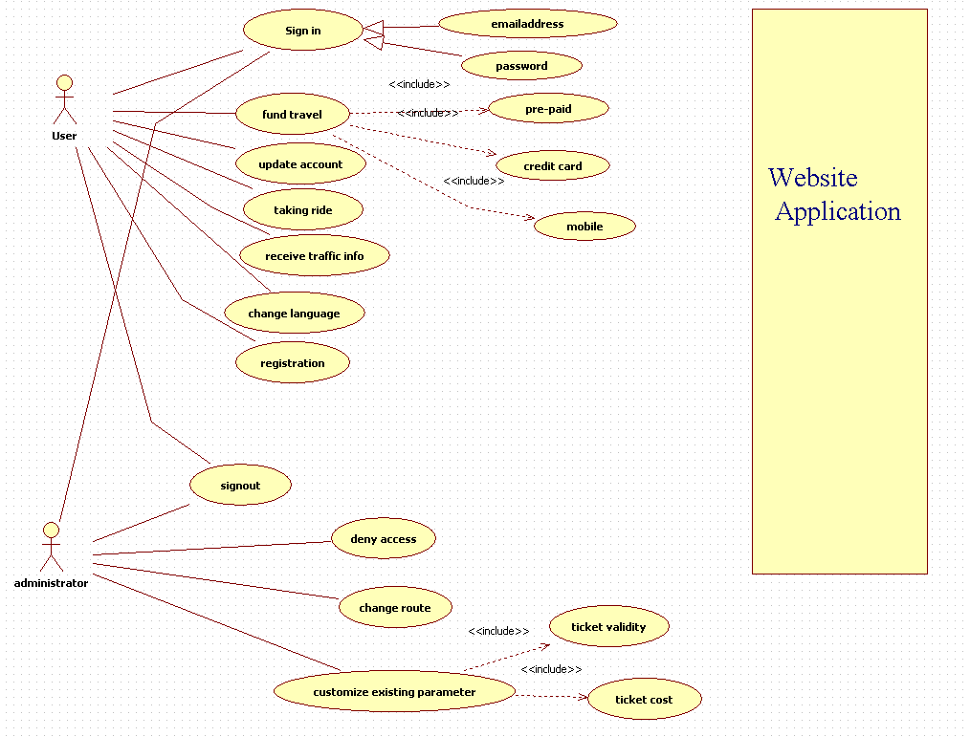

Use case: User Registration
Initiator:
Public transportation system user
Goal:
To register himself as a public transportation system user

Main Scenario:
- User desires to register.
- User gives his personal information on the website
- Downloads the Mobile application from the Android Market (Link provided on website).
- User uses mobile application to retrieve Bluetooth and Wi-Fi Address
- User Provides information regarding the mobile handset(Mac Address)
- User specifies his preferences regarding Notifications (e.g. route optimization)
- Web application validates the provided input
- User details are recorded.
- User is registered successfully.

Extensions:
If the user enters invalid or incomplete information, he is notified and is given an opportunity to correct and provide complete information.

Use case transfer funds into prepaid account
Initiator:
EzFare system user

Goal:
Transfer of funds into his personal prepaid account

Main Scenario:
- User logs into the Web application.
- Chooses the mode of payment.
- User inputs payment amount and details
- Specified amount is transferred to user’s personal prepaid account
- Confirmation is shown to the user.

Extensions:
If the transaction could not be done, user is notified and no new funds appear on user’s prepaid account.
The user can be notified on successfully recharging his account.

Use case account deletion
Initiator:
EzFare system user himself or the authorized administrator

Goal:
To delete the user from the list of authorized users

Main Scenario:
- The user himself, or the administrator mark the user for deletion
- The system asks for confirmation
- The system logs the deletion and deletes the user
Extensions:
The initiator can abort the process in step 2.

Use case account detail modification.
Initiator:
EzFare system user

Goal:
To modify details in the system

Main Scenario:
- User uses the web application to login to the system
- User modifies the required data and submits it.
- The system validates the information.
- The system logs the change.

Extensions:

The user can be notified via SMS on the modification of data.

Use case model: User interaction via mobile phone
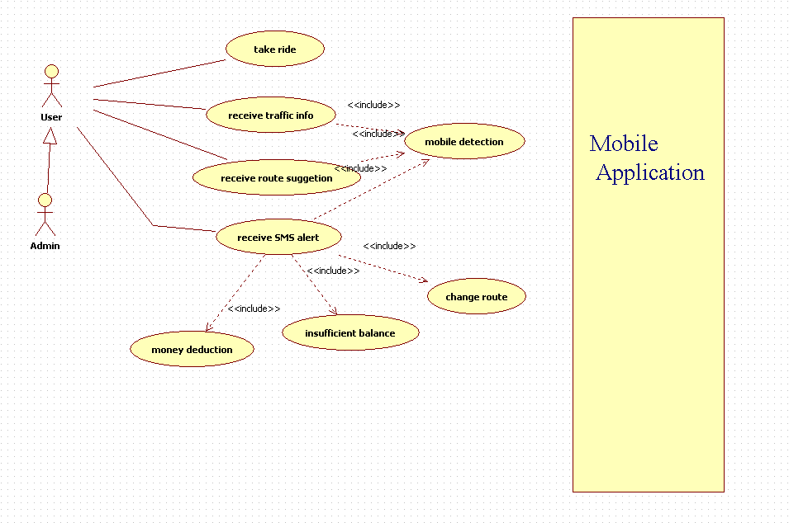

Use case taking a ride on the public transportation vehicle (FULLY DRESSED)

Initiator:
EzFare system user

Stakeholders and Interests:

-User: wants to reach a certain destination. Wants to purchase a ticket with minimal effort, wants proof of purchase.

-MTA: Wants users to pay for their trips. Also, wants to improve quality of service by tracking the user’s trips
.
-PG: Wants to receive digital authorization requests in the correct format and protocol.

-Police: Wants to know of transgressions.

Preconditions: The user has registered, installed and started his Mobile application. Vehicle has arrived at a station.

Postconditions: The user has paid the fare, and has arrived at his destination. Information about his trip was saved in the system.

Main Success Scenario:
- User gets on the Vehicle
- VU recognizes that the user has entered the vehicle via the MA.
- VU authorizes the user.
- VU informs the Mainframe of the User and its Location.
- Mainframe checks for Ticket validity.
- User leaves the Vehicle at a Vehicle stop.
- VU informs the Mainframe that the user has left
- Mainframe stores the relevant data.
- The user has reached his destination.

Extensions:
5a. Ticket isn’t valid.
- Mainframe deducts the funds from the User’s balance.
1a. User has insufficient funds on his balance
- Mainframe charges the fare to the User’s credit card

1b. User has insufficient funds on his balance and is in debt.
- Mainframe notifies the Police of the User’s transgression.

2. Mainframe notifies the customer via SMS of the purchase.

9a. the user hasn’t reached his destination, changing Vehicles.
1. User enters another Vehicle.

Frequency of Occurrence: Continuous.

Use case traffic problems
Initiator:
EzFare system
Goal:
Notify the user that there are traffic problems on his usual route and suggest an alternate one

Main Scenario:
- A traffic problem is reported in the system
- Users who’s usual route is affected by the problem are notified and an alternate route is suggested

Extensions:
2a. if no alternate route exists; the user is just notified about the traffic issues

Use case better route suggestion
Initiator:
EzFare system
Goal:
Informing the user of a more optimal route than his usual one

Main Scenario:
- The system analyzes the user’s usual routes
- If a better route is found, the user is notified

Use case model: System administration

Use case beginning customization
Initiator:
EzFare system administrator
Goal:
Setting up the system and customizing it for a specific public transport system

Main Scenario:
- Administrator makes a configuration file that adheres to a specified standard in which he specifies all the parameters, including lines, payment models, user types, etc
- The file is fed into the EzFare system, which configures itself accordingly

Extensions:
If an error is found in the configuration file, the administrator is notified

Requirements Definition

Requirement Group Definitions

Identification | Requirement Group | Rem.
UTI | User tracking and informing
PYM | Payment
SA | System administration
NFR | Non-functional requirements

Requirement Sources

Source | Description | Rem.
Stud | Students working on the project
Sys | Required as a consequence of system design (contractor’s requirement)
SCORE | Customers from the SCORE contest.

Requirements definitions

Identity | Status | Priority | Description | Source
 |  |  | User tracking and informing
UTI-1 | I | 2 | Tracking the user’s usual routes | SCORE
UTI-2 | I | 1 | Recognizing when the user enters or exits the vehicle | SCORE
UTI-3 | I | 2 | Notifying user of changes in routes or traffic problems | SCORE
UTI-4 | I | 1 | Enable users to register and view information via Web application | SCORE
UTI-5 | A | 3 | Optimizing User Routes. | SCORE
UTI-6 | A | 1 | The Vehicle Unit will recognize the User. | SCORE
 |  |  | Payment
PYM-1 | I | 3 | Enable secure payment channels | Sys
PYM-2 | I | 2 | Enable multiple payment options | Sys
PYM-3 | A | 1 | Notification of purchased fare via SMS. | SCORE
 |  |  | System administration
SA-1 | I | 1 | Allow defining of custom traffic grids and various Public transportation models | Sys
SA-2 | I | 2 | Allow visualization of collected data | Sys
SA-3 | I | 2 | Allow customization of existing parameters | Sys
 |  |  | Non-functional requirements
NFR-1 | I | 2 | Safety and security of all user information and money transactions | Sys
NFR-2 | I | 1 | Usability and an intuitive User interface | Sys
NFR-3 | A | 4 | The system shall be able to provide service at all time | Stud
NFR-4 | A | 5 | It will be easy to add new phones to the service | SCORE

Requirement status:
I = initial (this requirement has been identified at the beginning of the project),
D = dropped (this requirement has been deleted from the requirement definitions),
H = on hold (decision to be implemented or dropped will be made later),
A = additional (this requirement was introduced during the project course).

Change Log

Identity | Action | Date | Comments
UTI-5 | A | 2010-10-14 | Additional Costumer requirement.
UTI-6 | A | 2010-10-14 | Core Customer requirement.
PYM-3 | A | 2010-10-14 | Core Customer requirement.
NFR-3 | A | 2010-10-14 | It depends on other services.
NFR-4 | A | 2010-10-14 | Let’s get it working on Android, then we can worry later ☺

Requirement status:
D = dropped (this requirement has been deleted from the requirement definitions),
H = on hold (decision to be implemented or dropped will be made later),
A = added (this requirement was introduced during the project course).
R = resurrected (dropped or on hold requirement was reactivated)

Future Development

General Overview
This project can be used as a commercial product, and there are ways to add more features to it. When completed, basic modular architecture should be achieved, as well as the ability to customize the application to some extent according to the demands of the Public transportation system it’s being used on. The communication between the basic parts of the system should be done, with emphasis on robustness and security. The main opportunity to enhance the system would be to improve the user interface, if necessary, add more customization options, and porting the mobile application to different platforms, like the iPhone, Windows Mobile, Symbian, etc.

Modularity
The main aspect of the architecture that should be considered should be its modularity. The system is meant to be used in a number of diverse environments, and the key to the project’s success will be the ability to adapt. Modular architecture and very low coupling between system components should allow just that.

